|  |  |
| --- | --- |
| **Video Prices**  Size |  |
| Small Web | 20 |
| Big Web | 30 |
| NTSC/PAL/DV | 50 |
| HD720 | 85 |
| D1080 | 95 |

**CREDIT PRICES**

Credits Price $/Credit

1 $1.625 $1.625

6 $9.75 $1.62

12 $18.50 $1.54

26 $39.50 $1.52

50 $75.00 $1.50

120 $175.00 $1.46

300 $430.00 $1.43

600 $800.00 $1.33

1000 $1,250.00 $1.25

2000 $2,250.00 $1.12

5000 $5,250.00 $1.05

10000 $10,000.00 $1.00

20000 $19,000.00 $0.95

**CREDIT & ROYALTY PRICES**

**Commission Pricing:** Contributors Make 50% Commissions on All Sales. Simple, straightforward and very competitive in the stock industry.

**Audio Prices**

|  |  |
| --- | --- |
| Size |  |
| Non-lyrical web-only | 30 |
| Lyrical web-only | 30 |
| Non-lyrical all-media | 60 |
| Lyrical all-media | 60 |

**3D Prices**

|  |  |
| --- | --- |
| Size |  |
| Basic | 5 |
| Moderate | 10 |
| Detailed | 20 |
| Complex | 30 |

|  |  |
| --- | --- |
| **Photo Prices**  Size |  |
| XSmall | 2 |
| Small | 5 |
| Medium | 10 |
| Large | 15 |
| XLarge | 20 |
| XXLarge | 25 |
| XXXLarge | 30 |

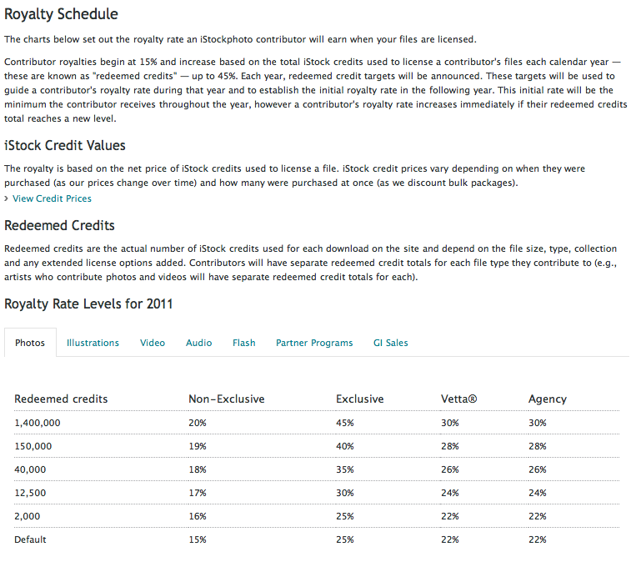

**REVO STOCK**

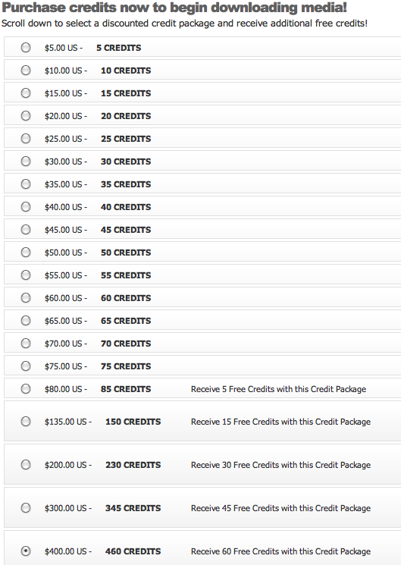

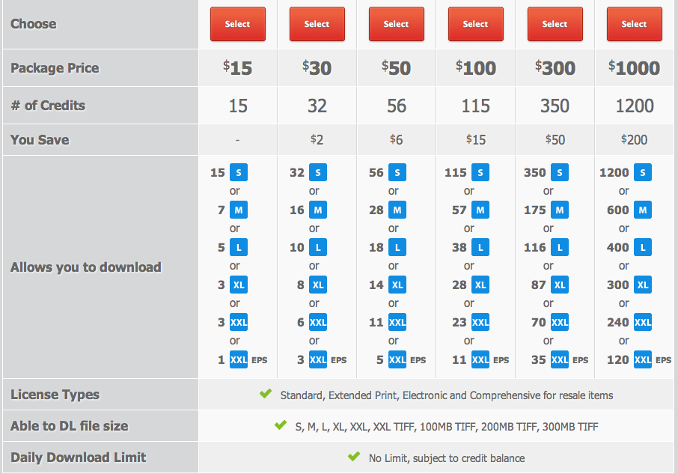



| Factor | Me | Strength | Weakness | Competitor A | Competitor B | Importance to Customer |
| --- | --- | --- | --- | --- | --- | --- |
| Products | 20 to 10,00 |  | X | MGN Online | Ddsd | Very Important |
| Price | competitive | X |  |  |  | Highly Important |
| Quality | In Progress | X |  |  |  | Highly Important |
| Selection | In Progress |  | X |  |  | Highly Important |
| Service | In Progress |  | X |  |  | Very Important |
| Reliability | In Progress |  | X |  |  | Very Important |
| Stability | In Progress |  | X |  |  | Important |
| Expertise | High | X |  |  |  | Important |
| Company Reputation | In Progress |  | X |  |  | Very Important |
| Location | N/A | N/A | N/A |  |  | N/A |
| Appearance | In Progress | X |  |  |  | Important |
| Sales Method | In Progress |  | X |  |  | Important |
| Credit Policies | competitive | X |  |  |  | Highly Important |
| Advertising | In Progress |  | X |  |  | Important |
| Image | In Progress | X |  |  |  | Important |